Ge thermal conductivity phono3py +VASP6.2.1

**Structure:**

To obtain the converged structure, a combination of energy cutoff, kpoint grid, along with a combinations of smearing method and widths are used.

* Smearing method Gaussian and Methfessel-Paxton was used to with smearing width (0.01, 0.05, 0.1, 0.15, and 0.30).
* Optimized Lattice parameters has little dependence on smearing method or width. With all the smearing method and width lattice parameters are within (0.002 Ang). Table below gives the optimised lattice parameters with varying energy cutoff, smearing method and smearing width. A = 5.70252 ang is used in all of our calculations. Please see file named “lattice_opt.xlsx” for entire data set. * note that lattice parameters are defined as per unitcell to felicitate comparison with experiments.

| **Ecut(eV)** | **Kpoint grid** | **Smearing method**  **and width**  **GS=0.15** | **Smearing method**  **and width**  **GS=0.1** | **Smearing method**  **and width**  **MP=0.1** |
| --- | --- | --- | --- | --- |
| 350 | 21x21 x21 | a =5.70198 ang | a=5.70224 ang | a=5.70205 ang |
| 400 | 21x21 x21 | 5.70226 | 5.70252 | 5.70233 |
| 470 | 21x21 x21 | 5.70233 | 5.70259 | 5.7024 |
| 520 | 21x21 x21 | 5.70226 | 5.70252 | 5.70233 |
| **600** | **21x21 x21** | **5.70227** | **5.70253** | **5.70234** |

**Harmonic Phonons**

* To test the convergence of phonon dispersion we tested the following combinations of supercell, energy cutoff, and k-points.
* Phonons are calculated at super-cell sizes of 333,444,555, and 666 with varying k points and energy cutoff's, and smearing method and width. Phonon dispersions are well converged at smearing with 0.1, for a given super-cell. Smearing method (Gaussian or MP) has little effect on phonons.
* We also checked the effect of Gamma centered and nono-Gamma centered mesh oh phonons. Both schemes give comparable results.

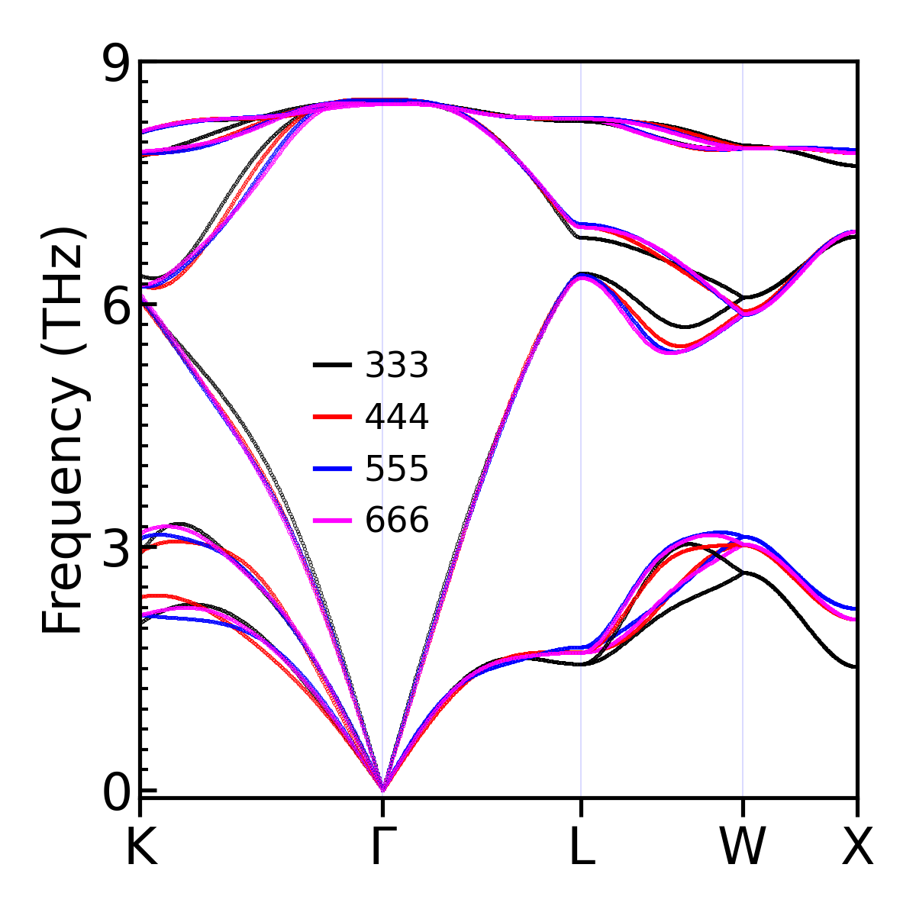

Fig1.Convergence of Phonon dispersion with respect to super-cell size.. Not great :(. method Gaussian. smearing width=0.15. On going from 5x5x5 to 6x6x6 cell the maximum change in phonon frequencies is 0.14 THz. ( A bit higher than the requested criteria of 0.1 THz).

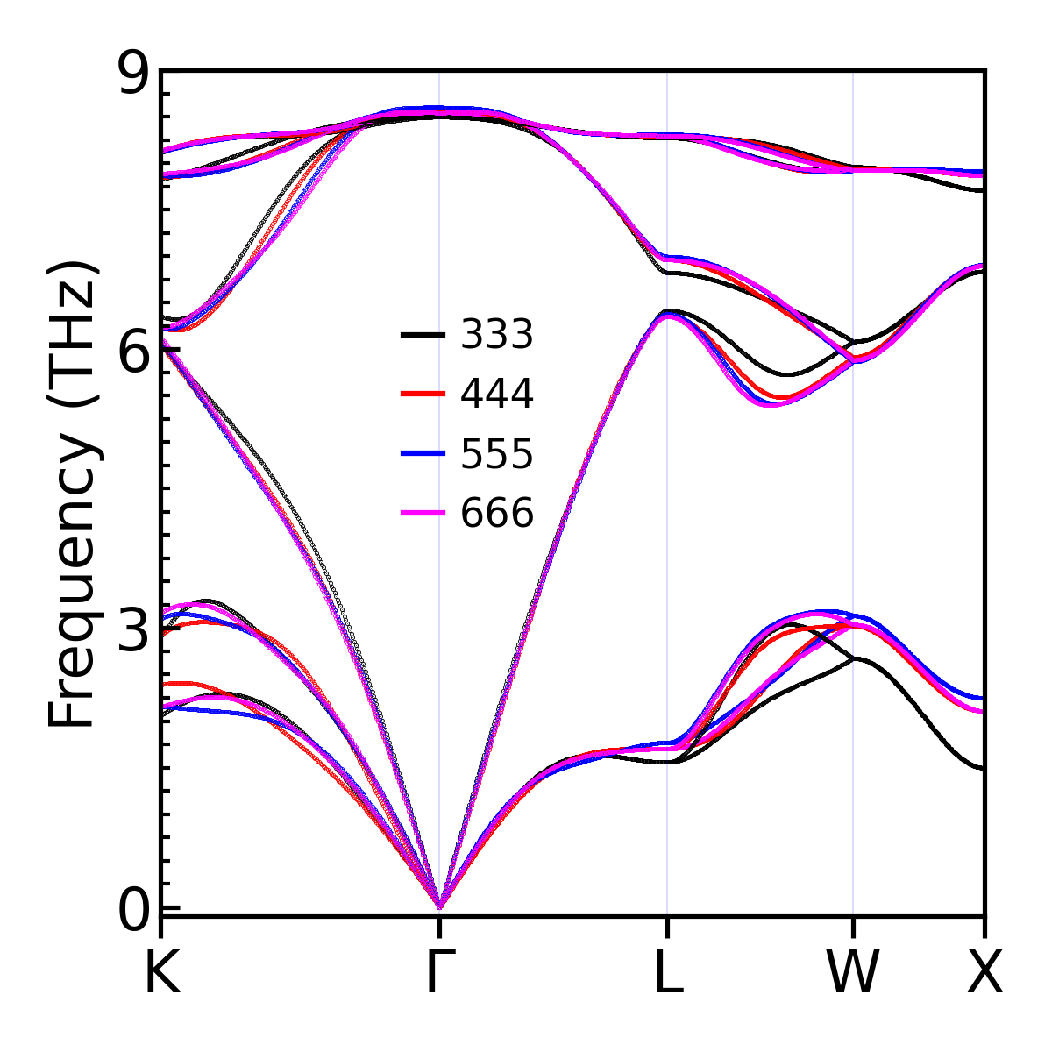

FIg2. Convergence of Phonon dispersion with respect to super-cell size.. method MP smearing width=0.15. On going from 5x5x5 to 6x6x6 cell the maximum change in phonon frequencies is 0.13 THz. ( A bit higher than the requested criteria of 0.1 THz).

FIg3. Convergence of Phonon dispersion with respect to smearing width. Supercell size =6x6x6, energy cutoff=600eV, kpoints=3x3x3 (G-centered), method= Gaussian. 0.15 eV smearing is used in our calculations.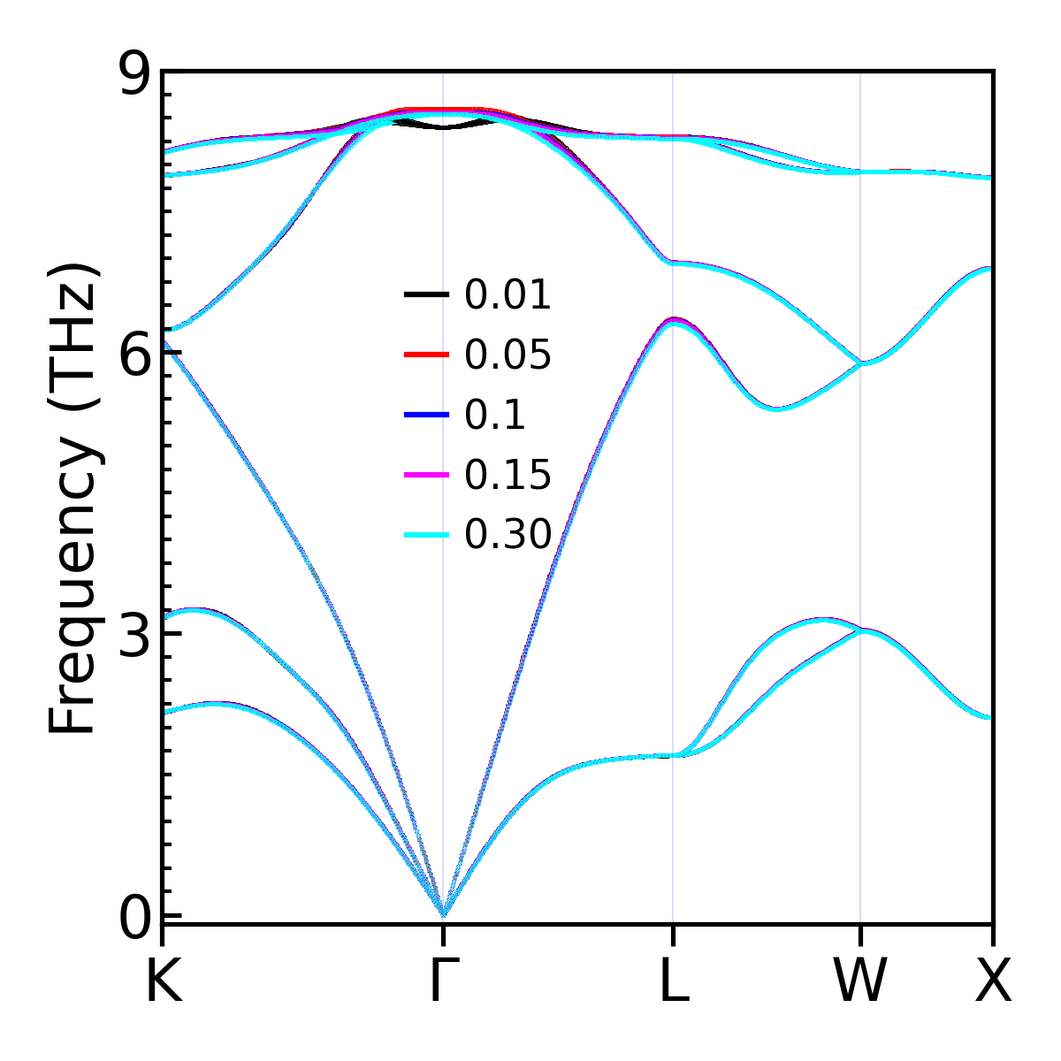

FIg4. Convergence of Phonon dispersion with respect to Supercell size, energy cutoff=600eV. Here Monkhorst-Pack scheme is used, and Gamma point is not included. 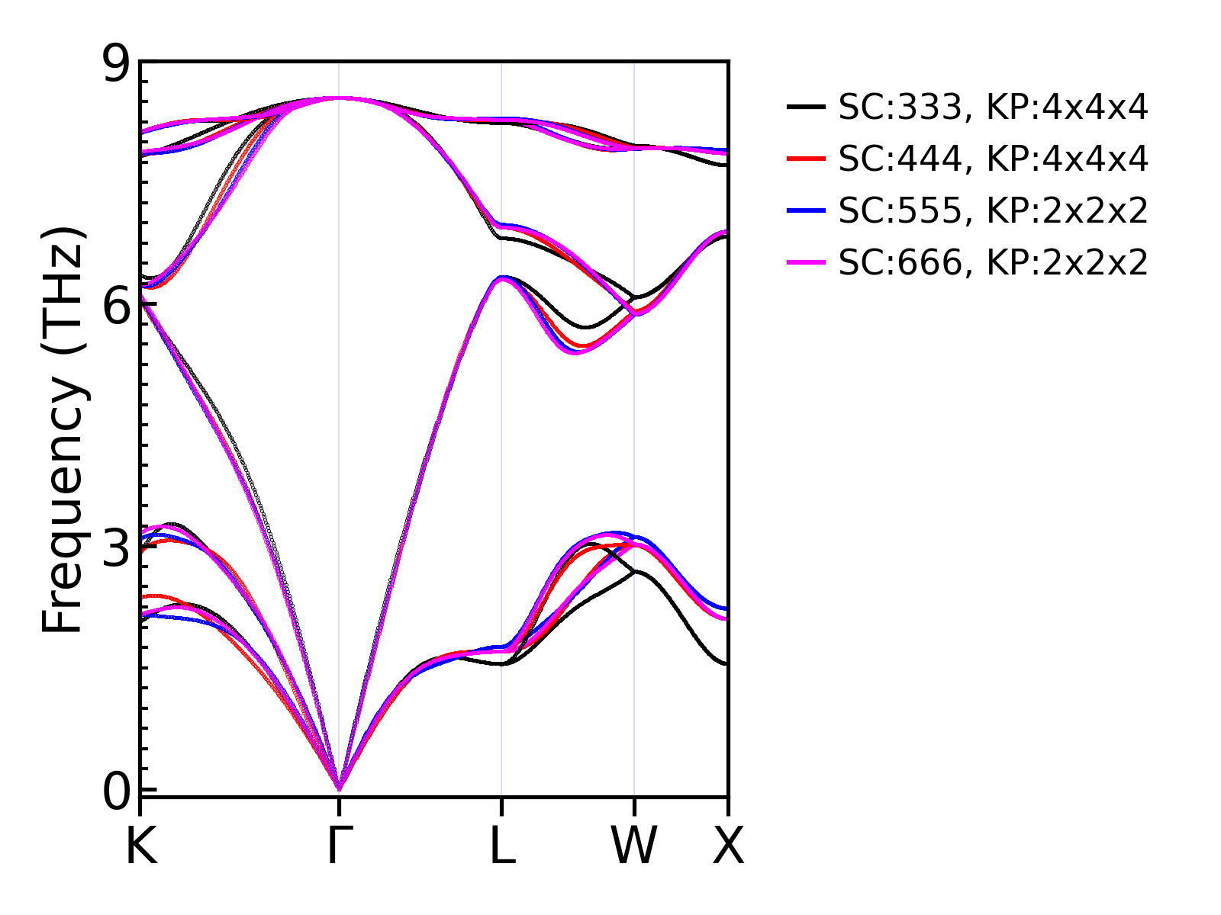

FIg5. Comparison of phonons obtained Gamma-centered and not gamma centered (MP) k-mesh of 2x2x2. Supercell size 6x6x6, and energy cutoff 600eV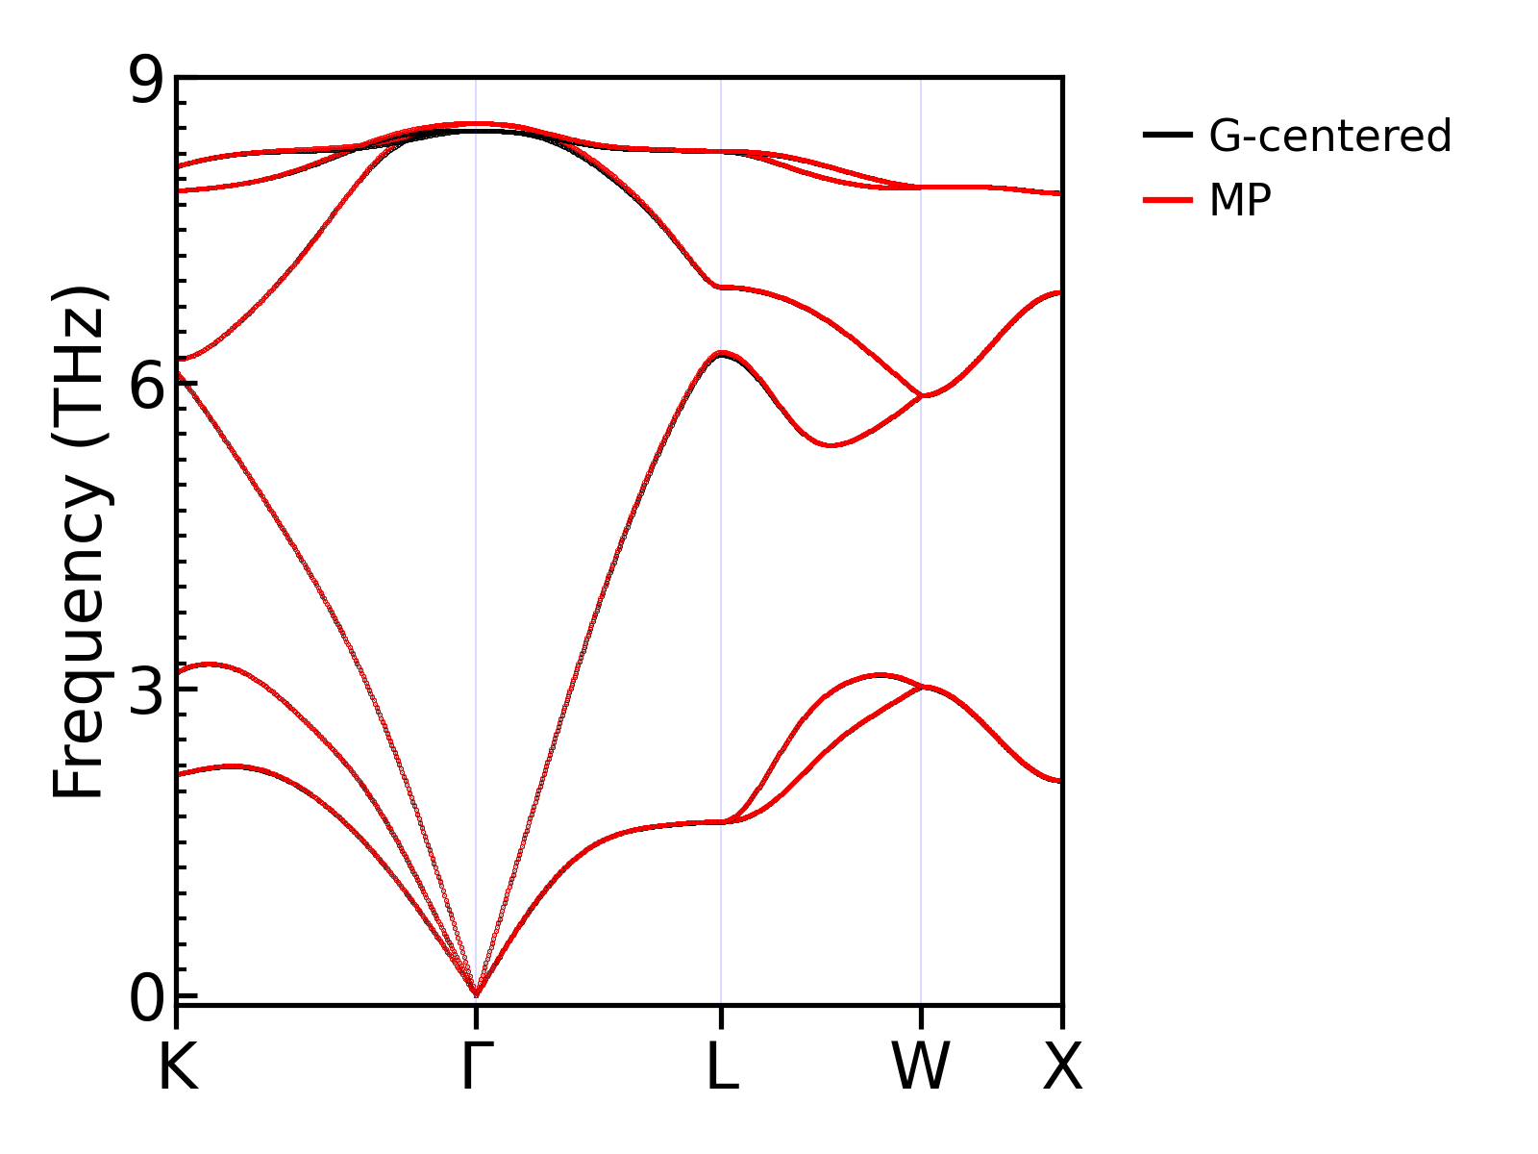

**Anharmonic phonons:**

* 3x3x3, 4x4x4, and 5x5x5 supercells were used to model anharmonic IFCs.
* In all three cases G-only, 2x2x2, and 3x3x3 k-mesh (G-centered) mesh was used along with an energy cutoff of 550eV.
* These calculations use Gaussian smearing with width 0.15.
* All possible interactions within the cells are included.
* To check the convergence of thermal conductivity with respect to interaction cutoff 3rd order Ifcs were created by truncating the interaction from full IFCS sets.
* We predict that thermal conductivity is well converged (within 1 W/m-K) on a 4x4x4 cell with 3rd order IFCs cutoff of 9.87659741 Ang.
* Thermal conductivity is converged for an integration grid of 41 x 41 x 41.
* Both tetrahedron and smearing methods were used to test the thermal conductivity. Smearing method with smaller Gaussian width (0.01) gives results comparable with tetrahedron method.
* We find that for case the 3rd IFCs are computed only with Gamma point the calculated thermal conductivity is a bit smaller.
* Thermal conductivity with 3rd order IFCs computed with 2x2x2, and 3x3x3 k-mesh are comparable.
* The effect of displacement amplitude used in 3rd order IFCs was also checked. We used 0.01, 0.03, 0.04, and 0.05 Ang. Calculated thermal conductivity decreases with increasing displacement amplitude.
* **For final converged results following parameters are used:**

**2nd order IFCs: supercell 6x6x6, kpoints=3x3x3 (G-centered), energy cutoff=600eV**

**3rd order IFCs, supercell 4x4x4, kpoints=3x3x3 (G-centered), energy cutoff=550eV**

**All possible interactions within the supercell are used**

**Thermal conductivity is calculated with a tetrahedron method with integration mesh of 41x41x41.**

**Electrons:**

* We use Gaussian and Methfessel-Paxton schemes with varying smearing width.
* Plane wave cutoff Ecut varied at 500 600 and 750 eV.
* Kpoints are varied as 11x11x11, 18x18x18, 21x21x21, and 24x24x24
* We tested both G-centered and Monkhorst-Pack (MP) k-points schemes. For even Monkhorst-Pack grid Gamma points are not sampled, and old MP -kpoints mesh are equivalent to old G-centered mesh.
* Energy threshold of 1e-08 eV
* For the even meshes Monkhorst-Pack is scheme is slower than Gamma-centered due to higher # of k-points.
* **I can not say what is the best smearing width to use. As smearing increases the overlap of conduction and valence bands increases (see Fig6, and Fig7) – perhaps smaller smearing width is best or the tetrahedral method to get the electronic band structure.**
* **Final calculations use a plane wave cutoff of 600eV, kpoints 24x24x24, Gaussian smearing with width 0.01.**

FIg6. Effect of smearing width on electronic bands,. kpoints grid 24x24x24 (G-centered), and Gaussian smearing method along with plane wave cutoff of 600eV is used here.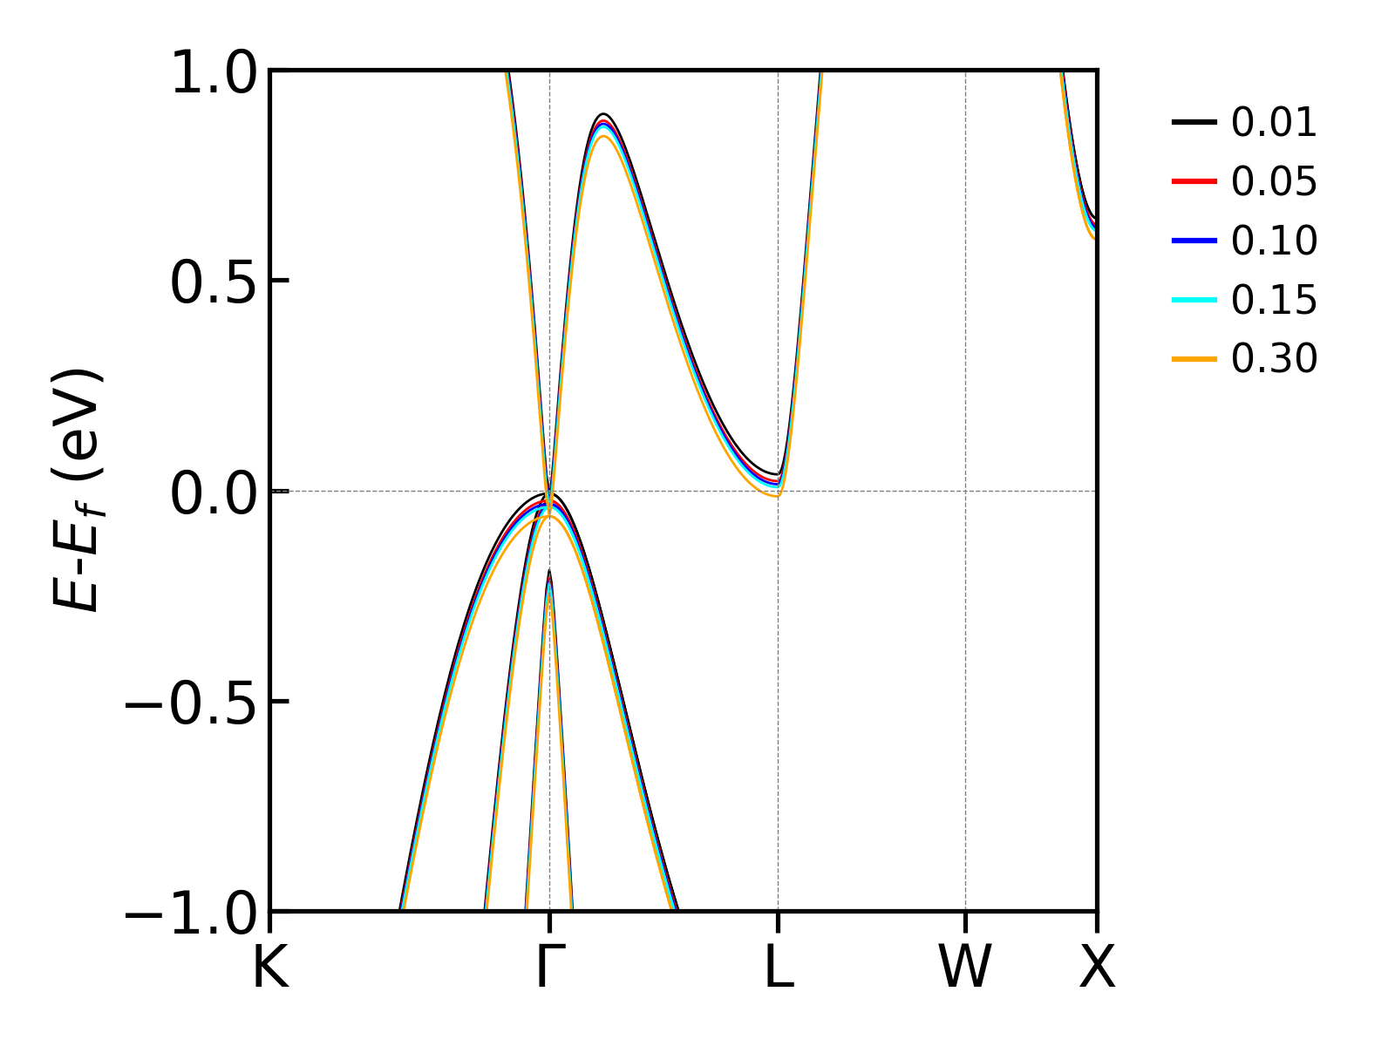

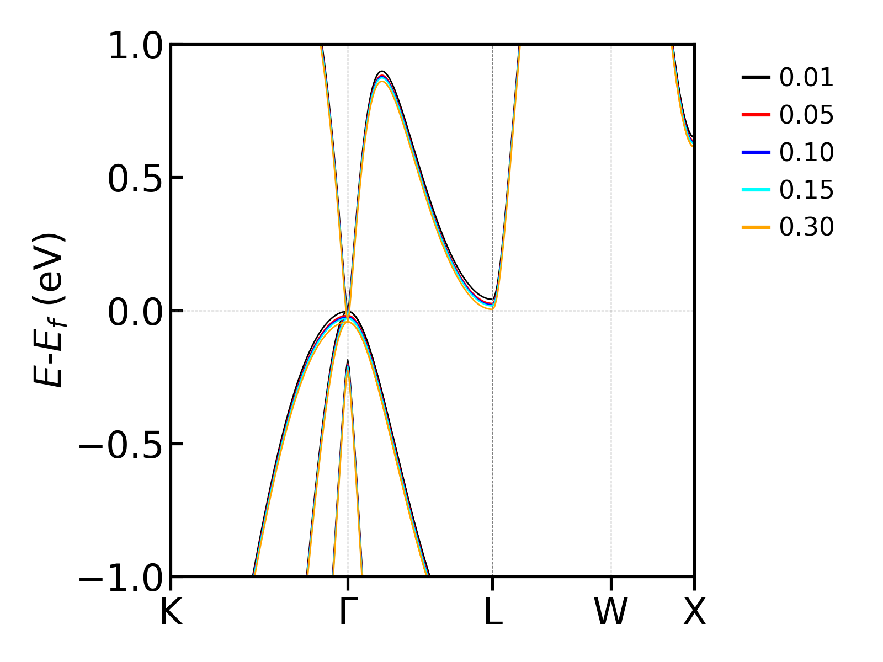

FIg7: Effect of smearing width on electronic bands,. kpoints grid 24x24x24 (G-centered), and Methfessel-Paxton smearing method along with plane wave cutoff of 600eV is used here.

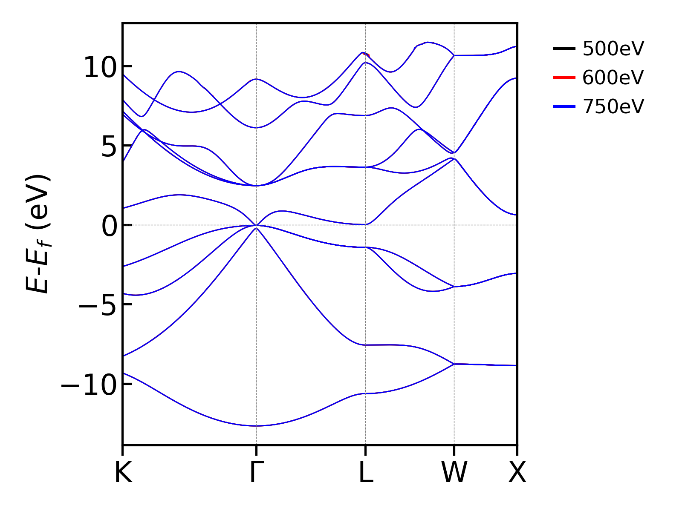

FIg8: Effect of plane wave cutoff energy cutoff on electronic bands,. kpoints grid 24x24x24 (G-centered), and Gaussian smearing with width of 0.15 are used here.

FIg9. Effect of kpoints grid on electronic bands. Plane wave cutoff is set at 600eV along Gaussian smearing with width of 0.15.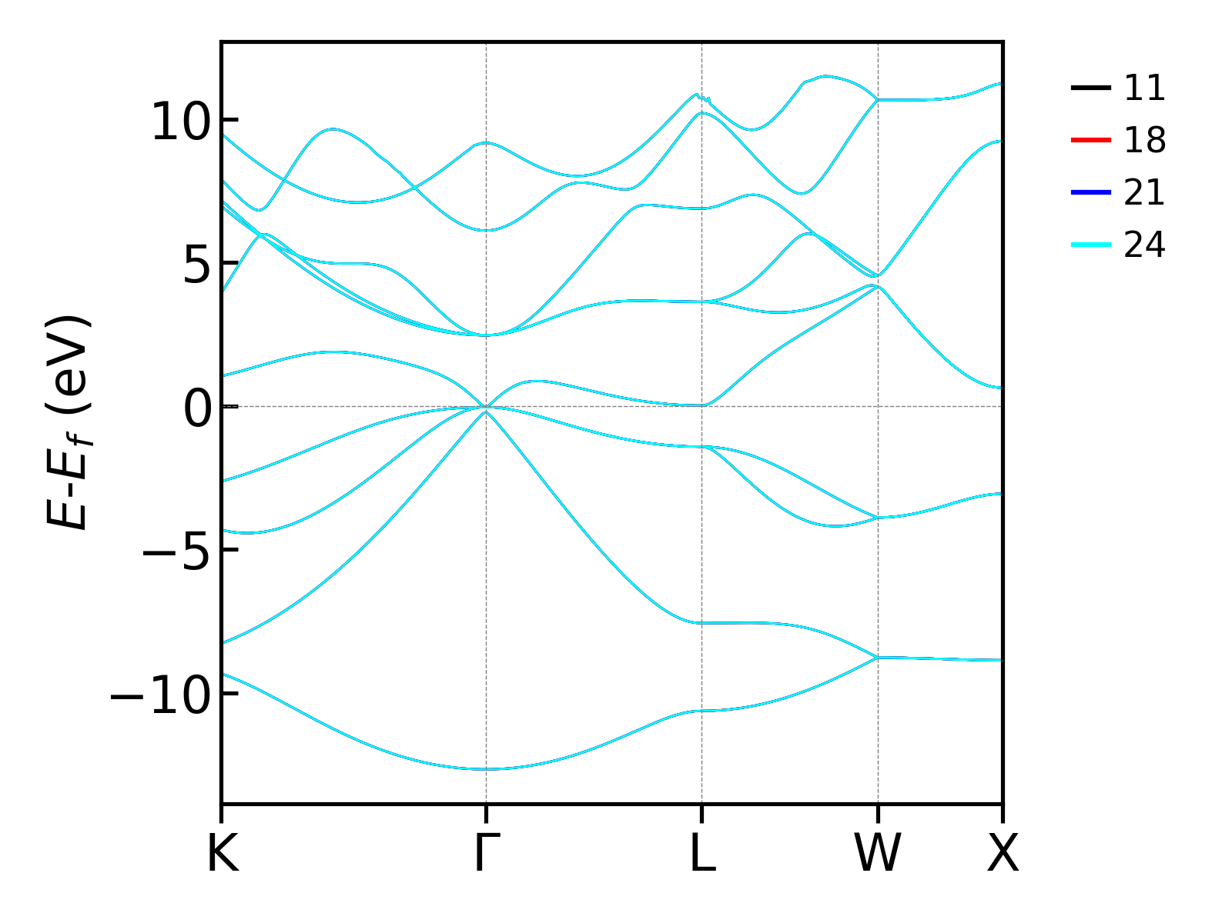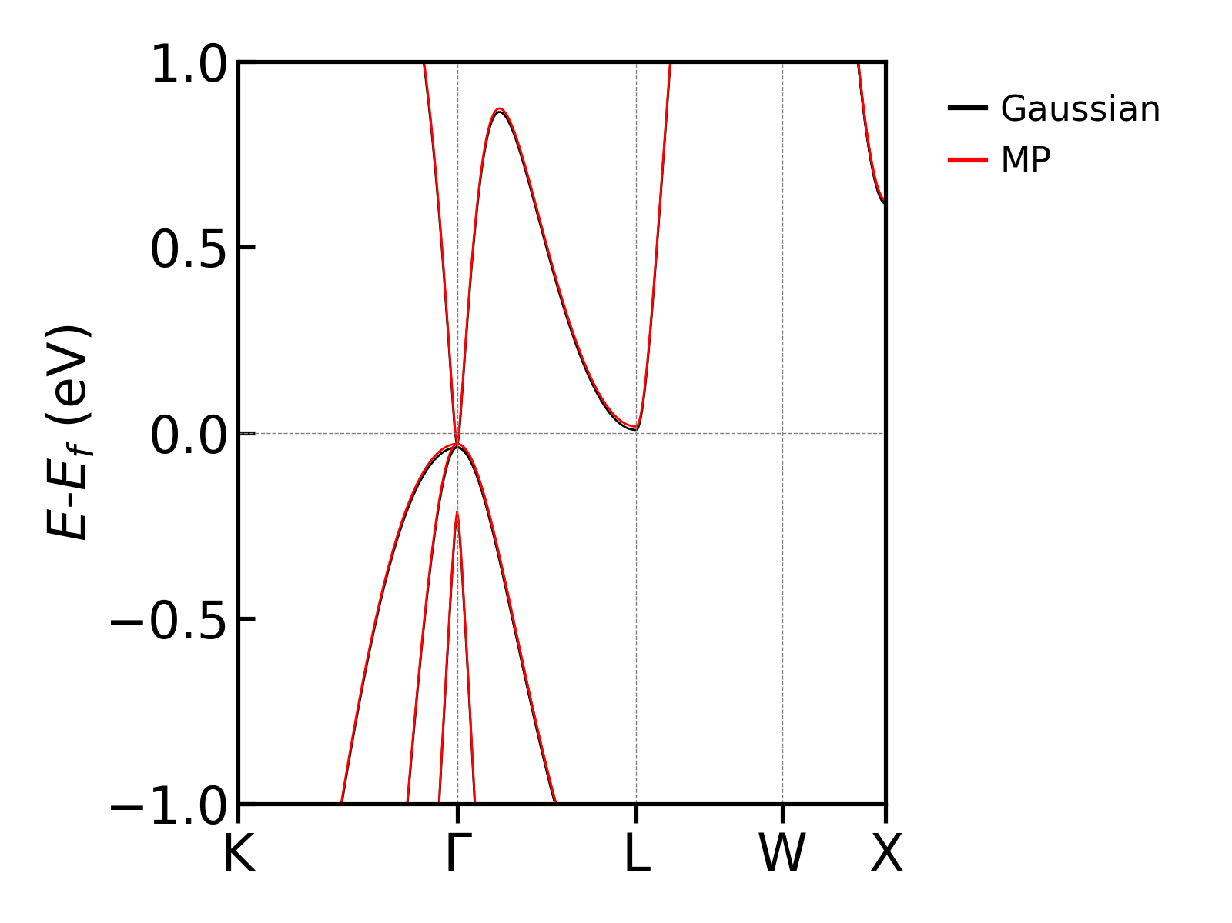

FIg10. Effect of smearing method (Gaussian smearing vs Methfessel-Paxton labeled as MP) on electronic bands. Plane wave cutoff is set at 600eV along with Gamma-centered k-grid of 24x24x24, and smearing width 0.15. Calculated energies are within 0.01eV.